Graduate employment boost as East Ayrshire Council offers business incentive

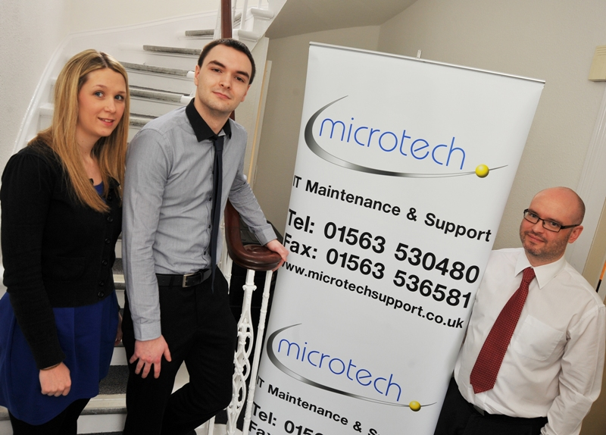
For Michael Stewart, who had been unemployed since graduating with a BSc in IT Networking last May, the graduate recruitment incentive has helped him into a dream job at Microtech, an IT support and maintenance company based in Portland Road, Kilmarnock.
As Claire Stanley of Microtech explains “We’re a growing company, providing installation, support and maintenance of IT systems throughout Scotland and Northern Ireland. We have a wide range of clients in the private and public sectors including the supply and support for the “docman” systems used in GP surgeries all over the country.
“We realised that we needed to recruit extra team members. Laura Neill of East Ayrshire Skills Development and Employability Service was tremendously helpful in making it happen. In the past we’ve had to draw up job specifications, advertise, trawl through CVs and then set up interviews. By working with Laura we avoided all that. She made the whole process much easier and as a result we’re delighted with Michael.
“We felt it was important to recruit someone local, who needed a job and a start in their career and whom we could train to our ways. Taking on a new graduate was ideal, Michael has the skills and knowledge to do the job but is also very used to learning new things and has tremendous enthusiasm. We’re so pleased with the way it’s working out we’ve already recruited another graduate with Laura’s help and he starts this week. The ongoing financial and practical support we are getting was instrumental in our decision to go ahead and recruit both graduates.”
Michael adds “I’ve only been here a short time but it feels longer. I’m really enjoying the job. The team here are all very hard working and dedicated but they still find time to be friendly, helpful and supportive. I’d been unemployed since finishing my degree and was finding it hard. So many employers just dismissed me because I had qualifications but no experience. I just needed someone to give me a leg up, a start in the industry. Although IT is a good sector for job opportunities, entry level jobs are hard to find. I’m very happy to have found this one.”

